Understanding disadvantage
As a Trust we are seeking greater equity through education, particularly for those who are presently (or previously) experiencing disadvantage. This session explores what it is to be disadvantaged, supports colleagues to reflect on their own experiences and explores ways of seeing the world through the lens of disadvantage. It will also explore how we apply equity to move the dial for the children and families that most need us. What if we are the hope and we fail? Particularly in more challenging and darkening times?

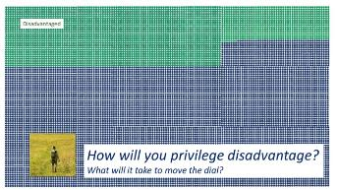
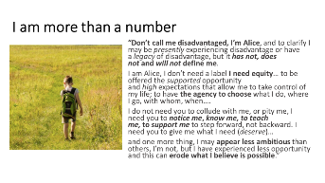
Key slides:
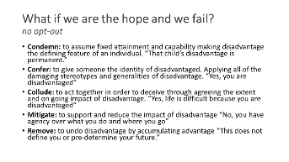
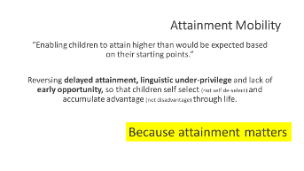

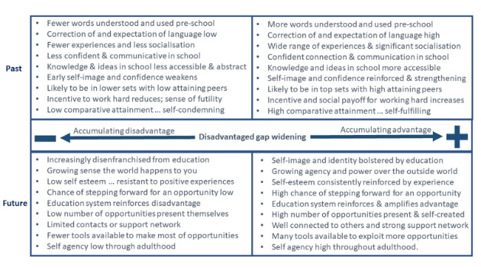

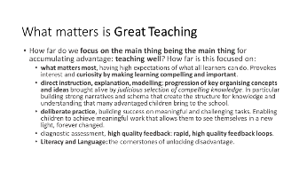
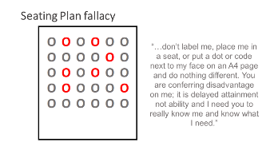

INTRODUCTION | understanding what it is to be presently experiencing disadvantage? (10 minutes)
Notes made during introduction

REFLECTION POINT ONE | Understanding how disadvantage accumulates? (10 minutes)
How can we tackle accumulated disadvantage? How far do you
recognise these forces in your life, personal or professional?

CASE STUDY | Principal reflection on disadvantage (5 minutes)
Notes on Academy Case Study

DISCUSSION POINT ONE | Reading case study: … How far do we recognise this? How do we achieve greater Equity Through Education? (10 mins)
“Fair doesn’t mean giving every child the same thing, it means giving every child what they need.” (Rick Lavoie)

"Don't call me disadvantaged, I'm Alice, and to clarify I may be presently experiencing disadvantage or have a legacy of disadvantage, but it has not, does not and will not define me. I am Alice, I don't need a label I need equity... to be offered the supported opportunity and high expectations that allow me to take control of my life; to have the agency to choose what I do, where I go, with whom, when.... I do not need you to collude with me, or pity me, I need you to notice me, know me, to teach me, to support me to step forward, not backward. I need you to give me what I need (deserve)... and one more thing, I may appear less ambitious than others, I'm not, but I have experienced less opportunity and this can erode what I believe is possible."

How far do we recognise this? What more can we do to overcome the forces of disadvantage? How do we achieve EQUITY THROUGH EDUCATION?

REFLECTION POINT TWO | Reading /Lone Journal reflection task (5 minutes)
Keep it simple | What matters is Great Teaching and (really) Knowing each child
- How far do we focus on the main thing being the main thing for accumulating advantage: teaching well? How far is this focused on:
  - what matters most, having high expectations of what all learners can do. Provokes interest and curiosity by making learning compelling and important.
  - direct instruction, explanation, modelling; progression of key organising concepts and ideas brought alive by judicious selection of compelling knowledge. In particular building strong narratives and schema that create the structure for knowledge and understanding that many advantaged children bring to the school.
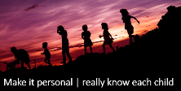
  - deliberate practice, building success on meaningful and challenging tasks. Enabling children to achieve meaningful work that allows them to see themselves in a new light, forever changed.
  - diagnostic assessment, high quality feedback: rapid, high quality feedback loops.
  - Literacy and Language: the cornerstones of unlocking disadvantage.

DISCUSSION POINT TWO | Sharing solutions and ideas (10 minutes)
Thinking about your work what will change tomorrow as a result of this session? How will you seek to support and enable those presently experiencing disadvantage?
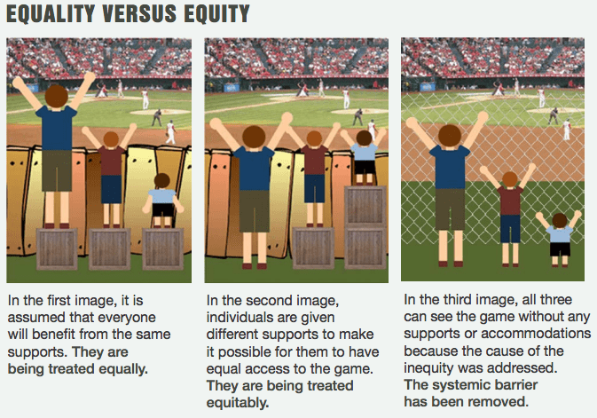

CONCLUSIONS | Chat feedback and next steps together ‘compelling action’ (5 minutes)
