The Curriculum Game

The aim of this session is to uncover our motivations for subject leadership. We will discuss how we build our expectations for and expertise with subject greatness in our teams and with all of our students. We will also consider how we talk about curriculum, its enactment and standards..
Key Slides
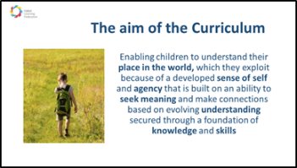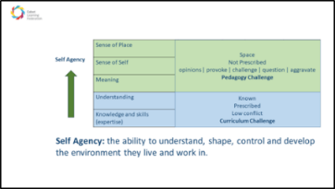

Why did you become a curriculum leader?
Personal reflection and note taking

What does it mean to be a curriculum leader? What is your quest?
Reading 1
“What is the quest of this discipline? All subjects seek to do something – or rather the people engaging in them are seeking to do something, either collectively or individually. This quest may have changed over time or a single discipline may encompass more than one quest. In science, the quest is to explain and predict the behaviours of the natural world through fundamental principles by observing and testing the world in a controlled manner. In geography, the quest is to understand how the earth and its resources interact with large-scale human behaviours by drawing on ideas from various fields and applying them to geographical cases. In history, we seek to understand the past by weaving together the remnants left for us. In art, the quest is to create visual pieces, for beauty, expression or both. In music, it is to create pieces in sound that are beautiful or evoke a particular emotion of experience. Understanding the quest of a discipline is vital to informing discussion of the recontextualisation, content and pedagogy of a school subject.”
Clare Sealy The Curriculum: Gallimaufry to Coherence Research Ed Series, 2020
Chapter 2 Ruth Ashbee

Personal reflection, reading and note taking
- What is your quest as a subject leader?
- What does curriculum leadership mean to you?
- What does Ruth Ashbee suggest are the different facets of subject and curriculum leadership?
- 5 minutes

Building Expertise and Enabling Beautiful Work

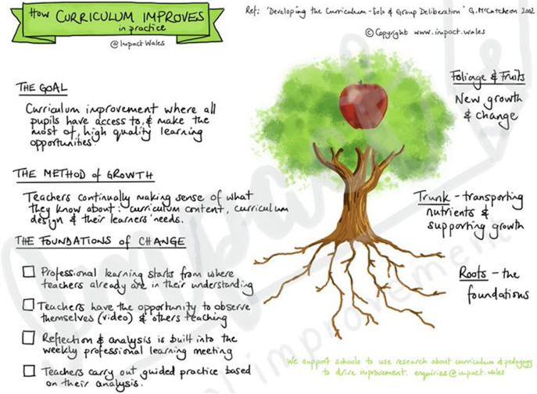

How do we build our expectations for and expertise with subject greatness in our teams and with all of our students?
Or, why and how am I teaching that?

Reading 2
Mary Myatt The Curriculum: Gallimaufry to Coherence John Catt 2018
Curriculum Purpose and Curriculum Coherence

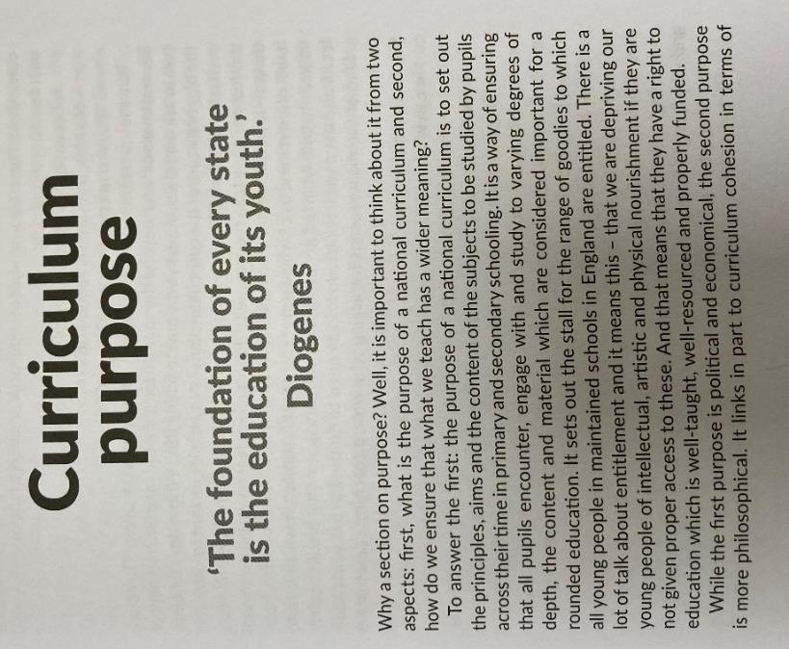
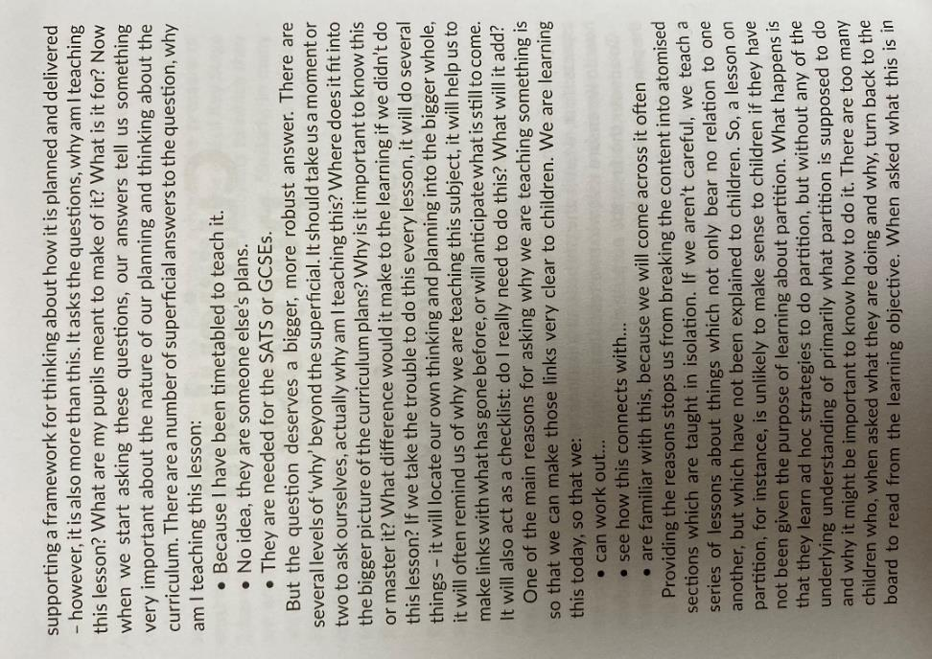
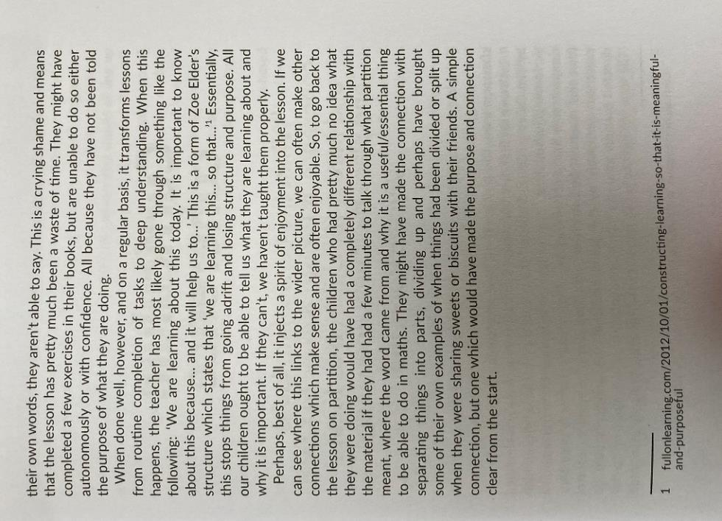
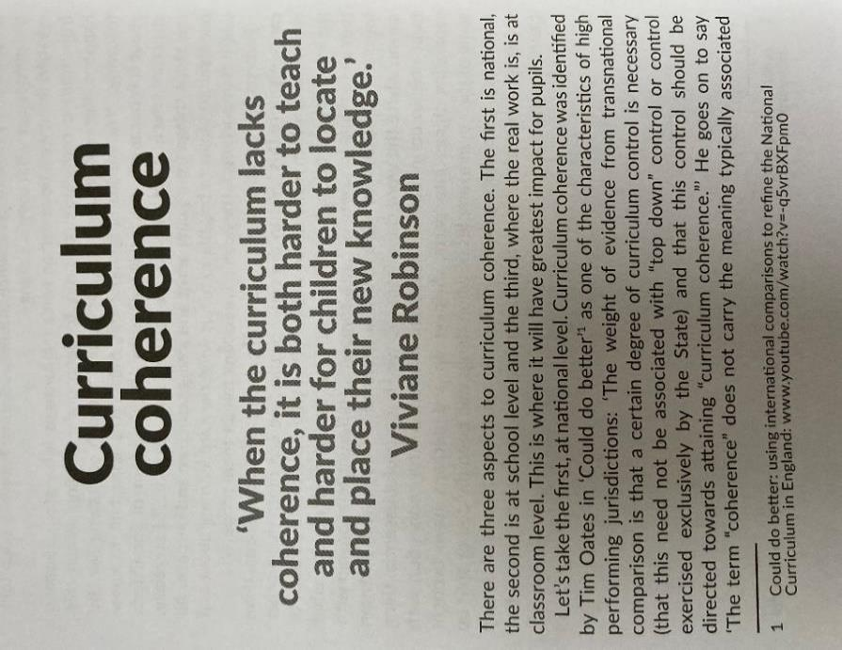
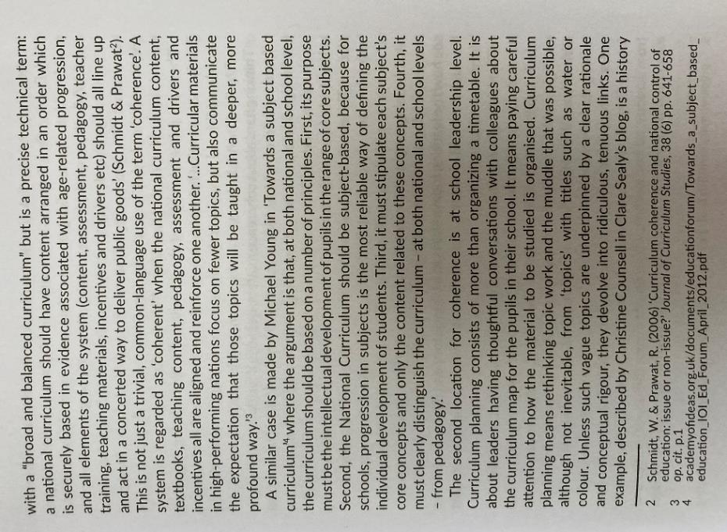
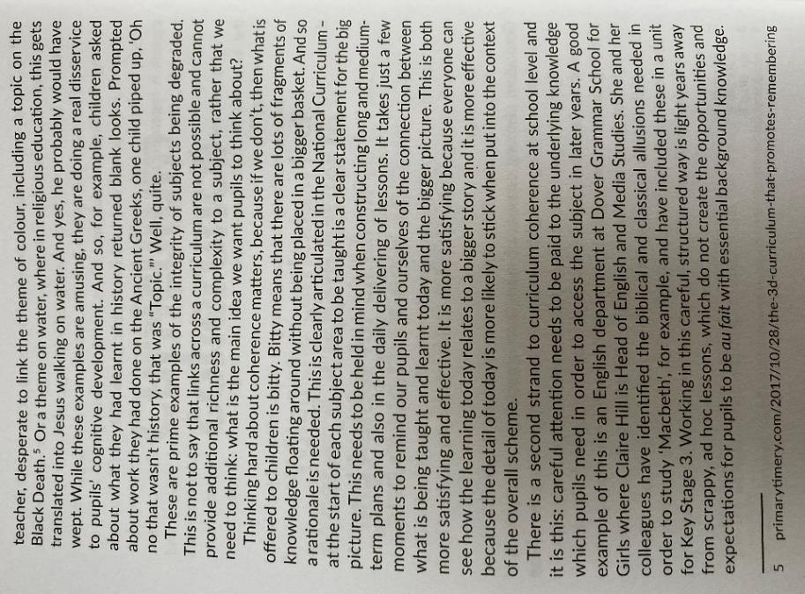

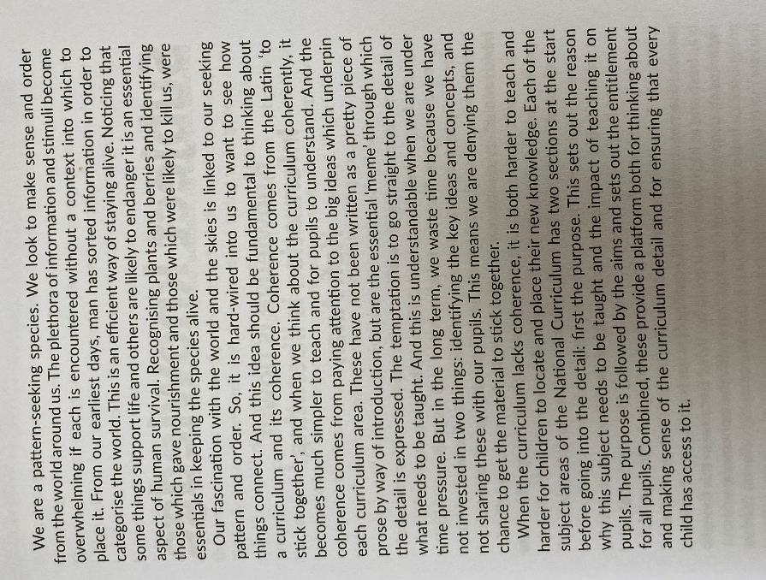

Personal reading, reflection and note taking in preparation for discussion
- What does Mary Myatt suggest about the following? How does it link to your leadership of the curriculum?
  - How do I develop my team? What do I know about their strengths and areas for development?
  - How do my team talk about curriculum, its enactment and standards?
  - Is there a subject specific pedagogy? What decisions do I enable my team to make about subject pedagogy?
  - How do I make sure that all learners are inspired by my subject?
  - What does beautiful work look like in my subject?
  - What do I do when I can’t see it in my classrooms?
- 10 minutes

Tell me about your curriculum
Role play
- Tell me about your curriculum?
- How does it work for your team in your setting and for your students?
- 10 minutes
- How did this feel? Commit your ideas to the chat when you return

Final thoughts
We are all advocates for great subject teaching, have extensive expertise and can change the experience and life chances of those experiencing disadvantage in our classrooms. What will you do differently?
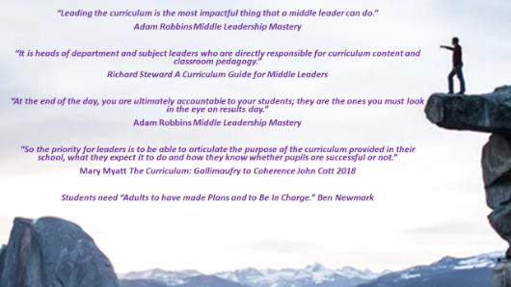

Further Reading

Ashbee, Ruth Curriculum: Theory, Culture and the Subject Specialisms, Routledge 2021
Lock, Stuart The Research Ed Guide to Leadership, John Catt 2020
Myatt, Mary The Curriculum: Gallimaufry to Coherence, John Catt 2018
Myatt, Mary and Tomsett, John Huh: curriculum conversations between subject and senior leaders
Robbins, Adam Middle Leadership Mastery, Crownhouse 2021
Sealy Clare The Research Ed Guide to the Curriculum, John Catt 2020
Steward, Richard A Curriculum Guide for Middle Leaders, Routledge 2021
In addition, a selection of blogs, Tweeters and extensive writers with a variety of perspectives:
- Chartered College https://impact.chartered.college/
- Counsell, Christine https://thedignityofthethingblog.wordpress.com/
- Myatt, Mary https://www.marymyatt.com/
- The Curriculum Journal
- Michael Young
- David Hughes
- Mark Priestley
- Mark Enser
- Sam Freedman
- Tom Middlehurst
- Josh Goodrich
- Ben Newmark
- Adam Boxer
- Sam Strickland
- Steve Rollett
- Peter Hyman
- Mick Walker
- Tom Sherrington

