Subject Matters

The aim of this session is to use our motivations for becoming teachers to understand the choices we make in our classrooms for our learners every day. We will consider ideas of subject greatness and subject passions and how we enable all learners to aspire to this too.
Key Slides
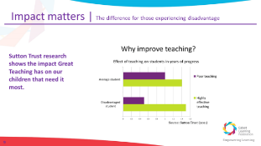
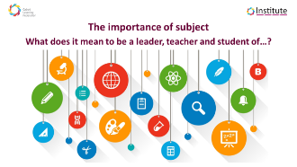
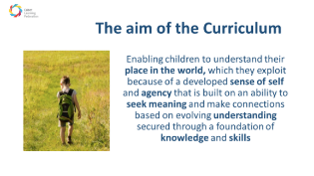

Why did you become a teacher?
Personal reflection and note taking

Subject Passions, Social Justice and Curriculum Ethos
Reading 1
“Each subject has its own lens or set of lenses to turn on the world, its own “gaze” to use the sociologists’ terminology. Noticing the light, noticing composition, seeking explanations, seeing wholes, seeing parts, seeking the right answer, accommodating multiple interpretations, relating to other works in the field such as writers in the same genre are all ways of looking and there are many many more. These gazes are often tacit for practitioners but they are worth making explicit in curriculum thinking. In fact, it is crucial that we do. If we fail to make the implicit explicit we will guarantee that many students will fail to understand how to make meaning in our subjects and will not be fully inducted into the ongoing cultural discourse. Although some students may come to experience a particular “gaze” through incidental osmotic process, this cannot be left to chance.”
Ruth Ashbee Curriculum: Theory, Culture and the Subject Specialisms Routledge 2021

Personal reading, reflection and note taking in preparation for discussion
- What's great about your subject?
- Why does your subject matter? What makes it matter?
- What does it mean to be a leader, teacher and student of…?
- Or, to use Ruth Ashbee’s phrase, what is the “gaze” of your subject?
- 5 minutes

Decisions for Subject Pedagogy
Why and how am I teaching that?

Reading 2

“…individual subjects: beautiful and worthwhile for their own sakes as well as fundamental to developing fully-rounded human beings.
There is a missing aspect to much curriculum planning and it is this: that too little attention is paid to the wider context and the bigger picture. For example, in science for KS1, pupils have to learn about herbivores, carnivores and omnivores. When you look at what is available for pupils to learn about these important categories, they mostly consist of sorting animals into Venn diagrams based on their feeding habits. There is nothing wrong with this, but it only takes their learning so far. They complete a worksheet, stick it in their book and that element of the curriculum is ticked and signed off as being ‘done’. However, in this example, as in many others which take a lesson-led objective approach to curriculum coverage, there is a great deal which is left out. Learning about herbivores and other animals is more than a worksheet. What would happen if pupils were shown clips or photographs from wildlife programmes and asked to make the same categorisation? What would happen if they learnt more than just the definitions? What would happen to their appreciation of language if they found out about the root of the word ‘omnivore’? What if they produced their own taxonomy?”

Mary Myatt The Curriculum: Gallimaufry to Coherence John Catt 2018

Personal reading, reflection and note taking in preparation for discussion
- How do you articulate subject greatness to your students and help them to aspire to equal greatness?
- What does great subject execution look like? How do you set expectations?
- What pedagogies do you choose and what is your rationale for choosing them? What do we learn from Mary Myatt?
- 5 minutes

Final thoughts
We are all advocates for great subject teaching, have extensive expertise and can change the experience and life chances of those experiencing disadvantage in our classrooms. What will you do differently?

Further Reading
Ashbee, Ruth Curriculum: Theory, Culture and the Subject Specialisms, Routledge 2021
Myatt, Mary The Curriculum: Gallimaufry to Coherence, John Catt 2018
Myatt, Mary and Tomsett, John Huh: curriculum conversations between subject and senior leaders
Sealy Clare The Research Ed Guide to the Curriculum, John Catt 2020
In addition, a selection of blogs, Tweeters and extensive writers with a variety of perspectives:
- Chartered College https://impact.chartered.college/
- Counsell, Christine https://thedignityofthethingblog.wordpress.com/
- Myatt, Mary https://www.marymyatt.com/
- The Curriculum Journal
- Michael Young
- David Hughes
- Mark Priestley
- Mark Enser
- Sam Freedman
- Tom Middlehurst
- Josh Goodrich
- Ben Newmark
- Adam Boxer
- Sam Strickland
- Steve Rollett
- Peter Hyman
- Mick Walker
- Tom Sherrington

