Reading requirements

The development of literacy skills is everyone’s responsibility within an academy; not just those who teach English. This session will look at the barriers which prevent some students from engaging with text, whether they are at primary or secondary school. We will look at a ‘typical’ day at a primary and a secondary school within our trust. We will see how students experience reading at school – including elements of learning to read and reading to learn. All students are either currently experiencing or have experienced disadvantage. You will see interviews with students at the end of their day. Collaboratively we will discuss how we could and should support learners like these in our classrooms.
Key slides:

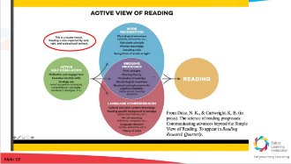
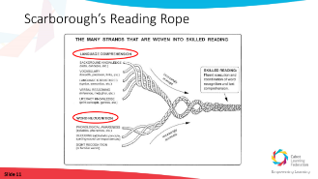

Notes made during introduction
The complexities of reading, learning to read and reading to learn.

Notes: general and setting specific barriers to reading (breakout groups)
What are the barriers which prevent students at your setting from accessing and understanding text?
Is there anything specific about your subject which makes it harder or easier for students to access text?

Notes: reading requirements at primary

Notes: reading requirements at secondary

Notes: solutions and ideas
What barriers and solutions have you discussed?
Add to your list and notes above considering the views of others.

Chat feedback and next steps together
Add to your list and notes above considering the views of others. List below what you will now do in your practice as a result of this discussion:

Additional Reading
The Active View of Reading N. Duke, K. Cartwright 2021
Every Teacher is a Teacher of Literacy, Teaching Across the Curriculum
Closing the Reading Gap by Alex Quigley
Disciplinary Literacy and Explicit Vocabulary Teaching by Kathrine Mortimore
Don’t Call it Literacy by Geoff Barton

