Pedagogy that privileges

This session will explore, through case studies, research and dialogue, the preferred pedagogical approaches that are proven to support our children to learn effectively.
Susie Weaver, with Case Studies and facilitation from Steve O’Callaghan, Craig Jones, Jan Saunders, Kath Cooper and Laurie Munro
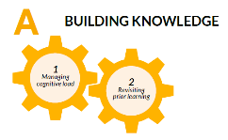
Pre-Reading option– Education and Architecture
https://educationendowmentfoundation.org.uk/news/eef-blog-education-and-architecture-a-cognitive-science-analogy
Introduction
How children learn and how we engage them in meaningful learning
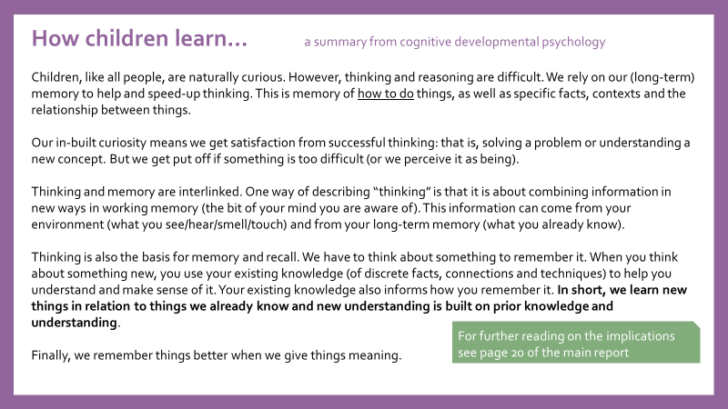

Memorable learning – Peps Mccrea
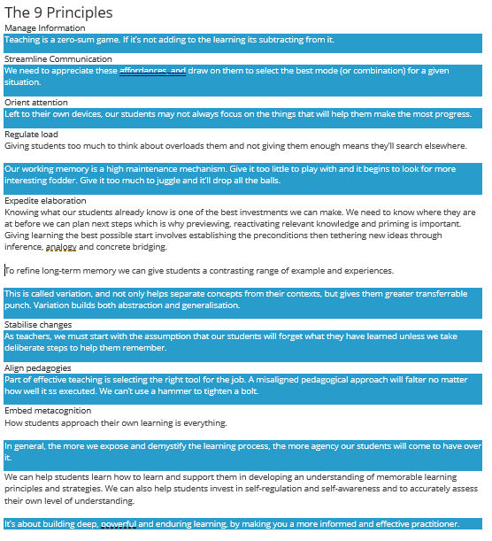
What are your reflections when reading the two descriptions of How children learn and what constitutes memorable learning?

How closely does your current teaching build deep, powerful and enduring learning?

Consider what you need in your own Professional Development to support you in becoming a more informed and effective practitioner.
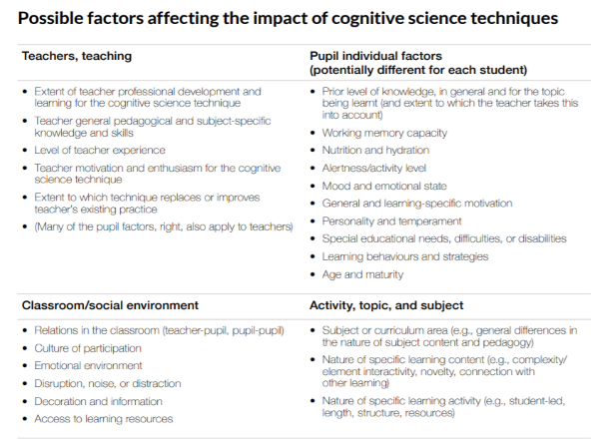
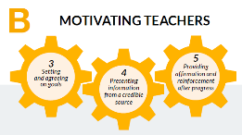
EEF factors affecting the impact of cognitive science techniques

What are your reflections when reading through the EEF possible factors affecting the impact of cognitive science techniques?
What do you think Dylan Wiliam means by this point?
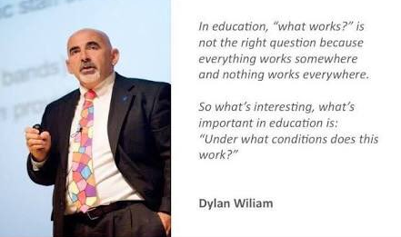
Case Studies and The hidden lives of learners
“If we are to understand how teaching relates to learning, we have to begin at the closest point to that learning; and that is students’ experience.” Nuthall. 2001.
"The most important single factor influencing learning is what the learner already knows" David Ausubel
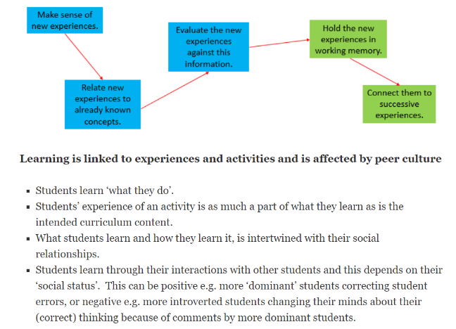
“There is a strong tendency to equate motivation with learning… if students are interested and involved in an activity, they will learn from it. Being attentive and engaged is equated with learning. However, students can be highly motivated and actively engaged in interesting classroom activities, yet not learning anything new. Learning requires motivation, but motivation does not necessarily lead to learning.”

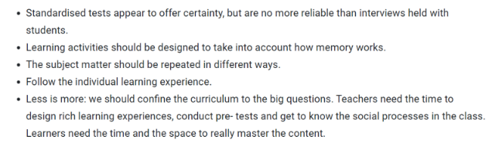
Standardised tests and more
Nuthall is advocating covering less of the curriculum in order to design and carry out effective learning activities. To what extent do you agree with this?

What does Nuthall mean when he says, ‘effective activities are managed by the students themselves?’

“Effective teaching means students learn what you intend them to learn… But whatever you intend, in order to know if you have been effective, you must have some way of knowing what your students believed, knew, could do, or felt before you taught them and what your students believed, knew, could do, or felt after you taught them. Learning, of whatever kind, is about change.”
“The central business of teaching is about creating changes in the minds of students – in what students know and believe and how they think. The ability to create change means that, in some way, teachers need to be constantly reading the minds of students. Are their minds focused? What are they understanding, or not understanding? What do they really think?”
When do you know for certain that a child in your class has really understood something?

How can a teacher find out what students believe, know, can do or feel prior to teaching?

How can a teacher find out what students believe, know, can do or feel after teaching?

Think of your learners, could any of them be ‘playing the game’ with you? How do you know?

How closely is our thinking aligned to this overview?
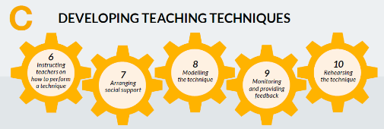
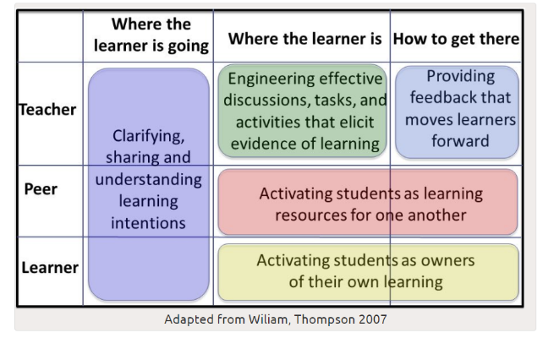

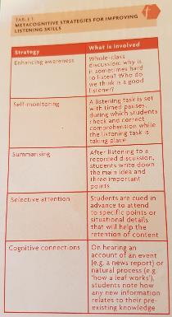
How much time is given over to learners
themselves REALLY listening and speaking?
What are the benefits and risks of creating a classroom environment where spontaneous peer talk can take place? Who is most at risk?

Is a teacher able to monitor and control the way concepts are shaped through peer talk?

Reflections – Using your professional judgement
“For all the insights that direct observation might provide, we should not base our evaluations of teaching on some universal model or set of models of good teaching. We simply cannot tell by looking…
Whatever is fashionable at the time determines what researchers look for and what they see”
What is your own measure of whether or not you are teaching effectively?

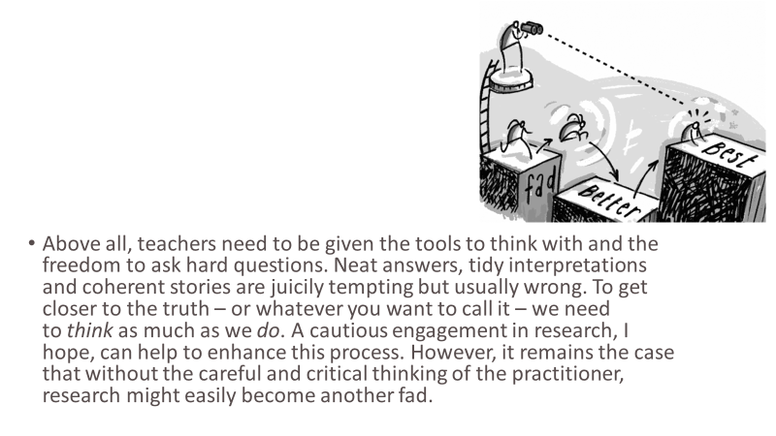
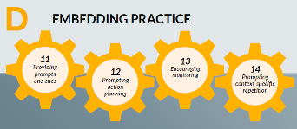
Further reading
http://tdtrust.org/about/dgt/

https://reflectingenglish.wordpress.com/tag/graham-nuthall/
https://my.chartered.college/2017/09/the-hidden-lives-of-learners-book-review-research-teachers-reflect/
https://improvingteaching.co.uk/2017/11/19/planning-lessons-using-cognitive-load-theory/

