Mental Health and Wellbeing; creating a supportive culture in our classrooms

Mental Health and Wellbeing awareness and promotion are an important feature of our work this year. Supporting students in these areas has been made ever-more paramount throughout the pandemic. This session will focus on collaborative problem solving around a shared case study of a learner experiencing disadvantage, Alisha. For Alisha, her mental health and wellbeing is a barrier to her education. Collaboratively we will discuss how we could and should support learners like Alisha in our classrooms.
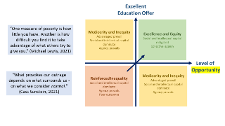
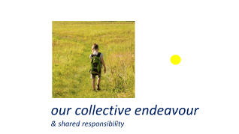
Key slides:
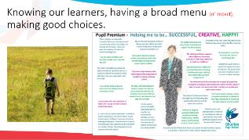
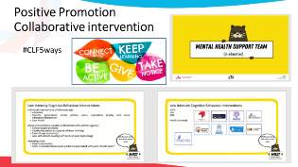

Notes made during introduction

Case study
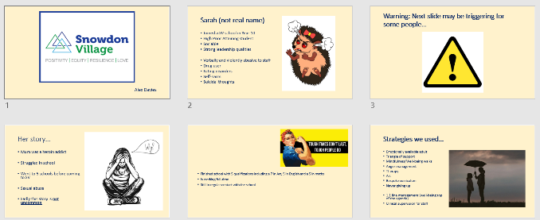

Sampson
- Calm, pleasant, confident
- No identified SEND
- GDS reading, writing and maths, loved mathematical problem solving.
Years 5&6:
- Angered easily.
- Outspoken - loud outbursts.
- Found problem solving increasingly difficult, did not want to reason. Wanted right/wrong.
- Refused to write. Would type.
- Behaviour incidents.
- Family where males did not talk about feelings.
- Withdrawn, head down, hoody up.

Reading /Lone Journal reflection task (5 minutes)
Read the above case study having heard about it from colleagues. Reflection task (5 minutes)
What are their barriers to positive MH&W?
What could be done to support these students to ensure positive MH is promoted?

Breakout rooms – sharing barriers/solutions (8 minutes) What barriers and solutions have you discussed?
Add to your list and notes above considering the views of others.

Coming back together for feedback/next questions (5 minutes)
Add to your list and notes above considering the views of others.

Breakout rooms – sharing solutions and ideas (10 minutes)
Think about a child you know who is experiencing, or might experience similar barriers to positive mental health and wellbeing as the students discussed today

- What could you do differently to support positive mental health and wellbeing

Notes:

Chat feedback and next steps together ‘compelling action’ (2 mins)
Add to your list and notes above considering the views of others. List below what you will now do in your practice as a result of this discussion:

