Habits of planning

The aim of this session is to delve into our habits of planning and to emphasise some habits of thinking about planning, using what we know from cognitive science and evidence, which could help to refine existing practice and ensure we plan teaching so that the learning is made accessible, and we remove barriers to learning, for all learners and especially those who have experienced or are experiencing disadvantage.

Key messages about planning
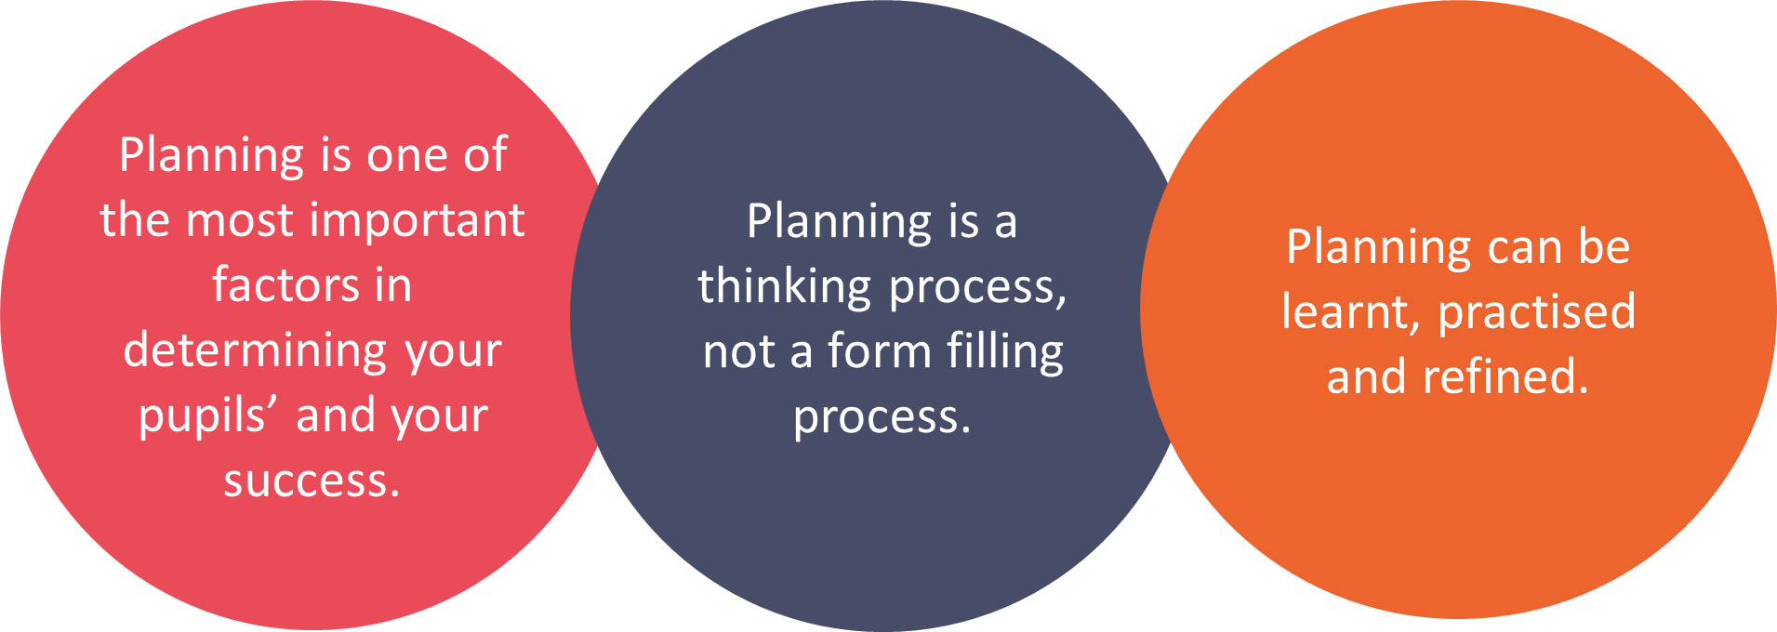
Read this extract from Peps Mccrea on Backwards Design

‘If you don’t know where you’re going, you’ll probably end up someplace else.’
Laurence Peter

I have worked with many teachers who have become frustrated by the planning habits they’ve developed over time. In some cases, this is because they have fallen unawares into one or both of the following classic traps.
- Activity-focused planning starts by trying to find a good activity, and then reverse engineering the lesson intentions to match the likely outcomes of the activity. Over time, this approach can end up becoming an exercise in keeping students busy.
- Coverage-focused planning begins with a set of lesson intentions that have been crafted by someone else (e.g. a colleague or a textbook), rather than taking the time to construct aims around your students’ needs. Over time, teaching can become an exercise in getting through the curriculum.

It is possible to experience some short-term gains with both of these approaches. They offer easy and compelling solutions to the problem of planning. However, they are economically flawed, and over time, are likely to stifle professional creativity and generate poor levels of return on student learning.
Starting with the end in mind

In his recent meta-analysis, John Hattie argues that one the best ways to optimise learning is to use backwards design. In the context of lean lesson planning this means two things.
- Start your planning with the question: what do I want my students to have learnt by the end of the lesson?
- Spending more time on this activity than you think you should.

Doug Lemov observed that effective teachers spend more time identifying outcomes and less time selecting activities than their colleagues. The clearer you are about where you want to go, the better chance you have of getting there. This logic may seem obvious, but in practice, it is frequently prone to abuse.

Backwards design is about striving for excessive clarity about what you want your students to be able to do as they progress through the lesson. This involves mapping out, breaking down and thinking hard about how the various parts of the learning trajectory hang together.

Mccrea, P. Lean Lesson Planning: a practical approach to doing less and achieving more in the classroom (2016)

- What are the key messages in this extract?

Introducing the habits of planning
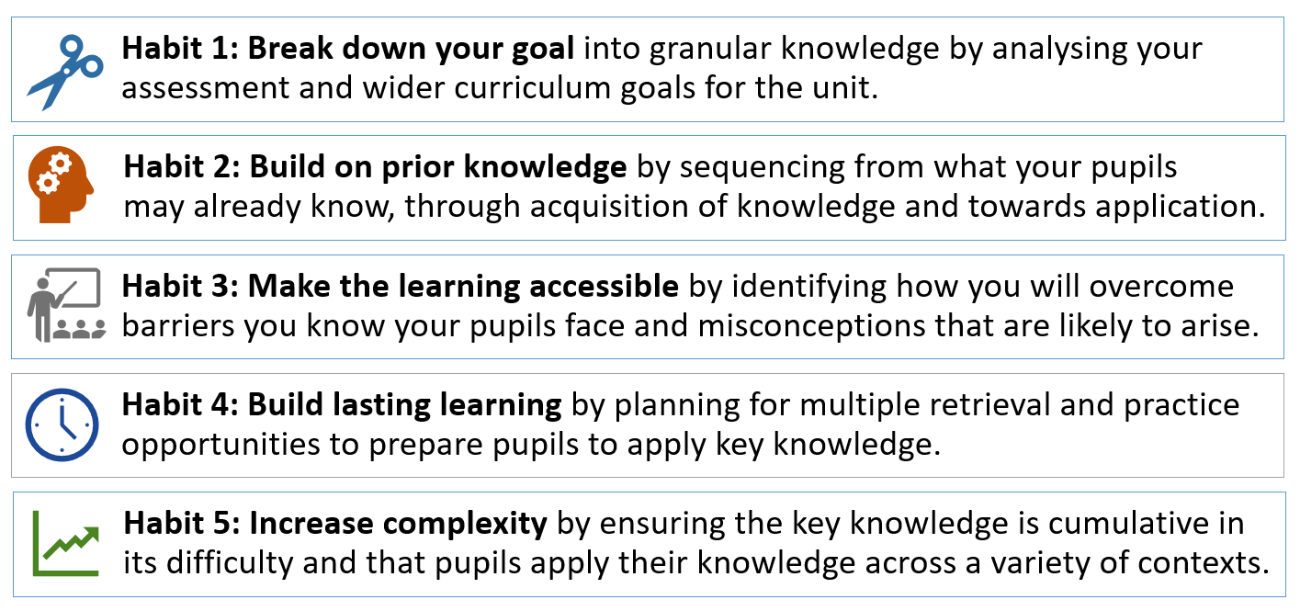

> What do you feel your current strengths are when planning?

> What would you like to improve on?

Task - Habit 2: Build on prior knowledge
Select one of the following scenarios, one you are most comfortable with or that best fits your teaching context. List the prior knowledge needed.
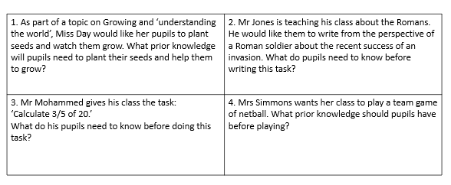

> What prior knowledge might be needed to complete this task?

> Look back through your list of prior knowledge that pupils need. Sequence or number what pupils would need to know first in order to build their learning.

Task – Habit 3: Make the learning accessible
Consider an upcoming lesson or unit of work that you will be teaching.
> What misconceptions may arise?

> What barriers may pupils have?

> How will you plan to overcome these?

Strategies to develop deep learning – Habit 5: increasing complexity
> Ensure acquisition before application
> Apply learning to a range of different contexts
> Ask open ended questions that promote higher order thinking e.g. ‘Why…’ based questions.
> Use a range of examples and non-examples

>What might an example and non-example look like for an upcoming topic or unit of work that you will be teaching?

Reflection
> What impact will this have on your teaching?

> What impact will this have on your pupils?

> What is your main takeaway from today’s session?

> Do you have any next steps? How will you hold yourself accountable for this?

Further Reading
Hattie, J. (2003) Teachers make a difference: What is the research evidence?

Mccrea, P. (2016) Lean Lesson Planning: a practical approach to doing less and achieving more in the classroom

Willingham, D. T. (2003). Why Students Think They Understand – when they don't https://www.aft.org/periodical/american-educator/winter-2003-2004/ask-cognitive-scientist

