# **Equity through Assessment**

*The aim of this session is to consider what we mean by the question, “Is assessment fair?” We will think about the continuums of assessment design and use and look to answer this crucial question: “how do we plan for and use assessment to really know our learners?”*

**Key Slides:**

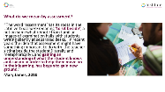  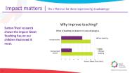

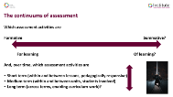 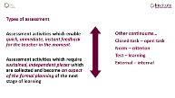 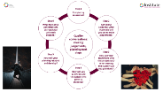

**Is assessment fair?**

|  |
| --- |
| **Personal reflection and note taking**  **A loaded term**   * Reading 1 * Consider the dictionary definitions and synonyms * Which of these words is most significant for you? * Which of these ideas is the most challenging in the classroom? * 3 minutes |

**Definitions:**

*Treating someone in a way that is right or reasonable, or treating a group of people equally and not allowing personal opinions to influence your judgment*

*If something is fair, it is reasonable and is what you expect or deserve*

*If a game or competition is fair, it is done according to the rules*

[**https://dictionary.cambridge.org/dictionary/english/fair**](https://dictionary.cambridge.org/dictionary/english/fair)

**Synonyms:**

* *unbiased*
* *impartial*
* *even-handed*
* *unprejudiced*
* *just*
* *clean*

[**https://www.collinsdictionary.com/dictionary/english/fair**](https://www.collinsdictionary.com/dictionary/english/fair)

**Bias, judgements and assumptions**

|  |
| --- |
| **Personal reflection, reading and note taking**  ***“…but bias isn’t really about forgetting. It’s about using assumptions to judge and evaluate, without necessarily being aware of the presence of those assumptions.”***  **Jessica Nordell**   * Reading 2 * When have judgements been made about you that you did not consider ‘fair’? * What would have prevented this? * 5 minutes * <https://www.theguardian.com/science/2021/sep/21/bias-that-blinds-medical-research-treatment-race-gender-dangerous-disparity> |

**Reading 2**

I met Chris in my first month at a small, hard-partying Catholic high school in north-eastern Wisconsin, where kids jammed cigarettes between the fingers of the school’s lifesize Jesus statue and skipped mass to eat fries at the fast-food joint across the street. Chris and her circle perched somewhere adjacent to the school’s social hierarchy, and she surveyed the adolescent drama and absurdity with cool, heavy-lidded understanding. I admired her from afar and shuffled around the edges of her orbit, gleeful whenever she motioned for me to join her gang for lunch.

After high school, we lost touch. I went east; Chris stayed in the midwest. To pay for school at the University of Minnesota, she hawked costume jewellery at Dayton’s department store. She got married to a tall classmate named Adam and merged with the mainstream – became a lawyer, had a couple of daughters. She would go running at the YWCA and cook oatmeal for breakfast. Then in 2010, at the age of 35, she went to the ER with stomach pains. She struggled to describe the pain – it wasn’t like anything she’d felt before. The doctor told her it was indigestion and sent her home. But the symptoms kept coming back. She was strangely tired and constipated. She returned to the doctor. She didn’t feel right, she said. Of course you’re tired, he told her, you’re raising kids. You’re stressed. You should be tired. Frustrated, she saw other doctors. You’re a working mom, they said. You need to relax. Add fibre to your diet. The problems ratcheted up in frequency. She was anaemic, and always so tired. She’d feel sleepy when having coffee with a friend. Get some rest, she was told. Try sleeping pills.

By 2012, the fatigue was so overwhelming, Chris couldn’t walk around the block. She’d fall asleep at three in the afternoon. Her skin was turning pale. She felt pain when she ate. Adam suggested she see his childhood physician, who practised 40 minutes away. That doctor tested her blood. Her iron was so low, he thought she was bleeding internally. He scheduled a CT scan and a colonoscopy. When they revealed a golf ball-sized tumour, Chris felt, for a moment, relieved. She was sick. She’d been telling them all along. Now there was a specific problem to solve. But the relief was short-lived. Surgery six days later showed that the tumour had spread into her abdomen. At the age of 37, Chris had stage four colon cancer…

Chris was told that her symptoms, increasingly unmanageable, were not serious. Women as a group receive fewer and less timely interventions, receive less pain treatment and are less frequently referred to specialists. One 2008 study of nearly 80,000 patients in more than 400 hospitals found that women having heart attacks experience dangerous treatment delays, and that once in the hospital they more often die. After a heart attack, women are less likely to be referred to cardiac rehabilitation or to be prescribed the right medication. Critically ill women older than 50 are less likely to receive life-saving interventions than men of the same age; women who have knee pain are 22 times less likely to be referred for a knee replacement than a man. A 2007 Canadian study of nearly 500,000 patients showed that after adjusting for the severity of illness, women spent a shorter time in the ICU and were less likely to receive life support; after age 50, they were also significantly more likely to die after a critical illness.

**How do we plan for and use assessment to really know our learners?**

**What can we learn from Dylan Wiliam?**

**Personal listening, reading, reflection and note taking in preparation for discussion**

* Listening https://youtu.be/sYdVe5O7KBE
* Readings 3 and 4
* Wiliam describes “constant readings”, what does this look like in your classroom?
* Think of one lesson next term
* What assessment opportunities will you add?
* What is the rationale for your choices?
* 10 minutes

**Reading 3**



**Reading 4**

**Dylan Wiliams’s Five Key Strategies**

1. Clarifying, understanding, and sharing learning intentions
2. Engineering effective classroom discussions, tasks and activities that elicit evidence of learning
3. Providing feedback that moves learners forward
4. Activating students as learning resources for one another
5. Activating students as owners of their own learning

***Embedding Formative Assessment***

**Leahy, Lyon, Thompson and Wiliam (2005)**

**Final thoughts**

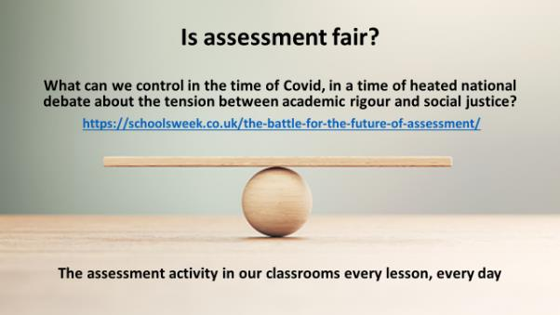

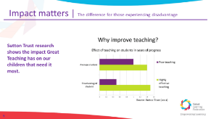 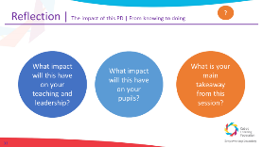

**What will you do differently?**

**Further Reading**

Assessment Reform Group (2002) Assessment for Learning: 10 Principles. Cambridge: University of Cambridge School of Education.

Biggs, J.B. and Collis, K.F. (1982) ‘Evaluating the Quality of Learning: The SOLO Taxonomy (Structure of the Observed Learning Outcome)’, New York: Academic Press Inc. Available at: https://doi.org/10.1016/C2013-0-10375-3.

Bloom, B.S. (Ed.), Engelhart, M.D., Furst, E.J., Hill, W.H., & Krathwohl, D.R. (1956). ‘Taxonomy of educational objectives: The classification of educational goals. Handbook 1: Cognitive domain.’ New York: David McKay. Available at: <https://www.uky.edu/~rsand1/china2018/texts/Bloom%20et%20al%20-Taxonomy%20of%20Educational%20Objectives.pdf>

Chartered College https://impact.chartered.college/

CIEA <https://www.herts.ac.uk/ciea/chartered-institute-of-educational-assessors>

James, M. (2010) ‘Educational Assessment: overview’, International Encyclopaedia of Education Third Edition, Volume 3, pp.161-171. Available at: DOI: 10.13140/2.1.1683.0243.

Leahy, Lyon, Thompson, Wiliam Embedding Formative Assessment 2005

Mansell, W. and James, M. (2009) ‘Assessment in Schools. Fit for Purpose? A Commentary by the Teaching and Learning Research Programme’, Assessment Review Group. Available at: <https://www.aaia.org.uk/storage/medialibrary/o_1d83e0m34athjb1ul11idd6r8.pdf>

Newton, P. E. (2007) ‘Clarifying the purposes of educational assessment’, Assessment in Education: Principles, Policy & Practice, 14(2), pp. 149–170. Available at: doi: 10.1080/09695940701478321

Nisbet, Isabel and Shaw, Stuart Is Assessment Fair Sage 2020

Qualifications Wales and CCEA Regulation (2019) ‘Fair access by design: Guidance for awarding organisations on designing high-quality and inclusive qualifications’. Available at: https://www.qualificationswales.org/media/4739/fair-access-by-design.pdf.

Wiliam, D. (2001) ‘Reliability, validity, and all that jazz’, Education, 3-13, 29 (3) pp. 17-21. Available at: https://discovery.ucl.ac.uk/id/eprint/10001156/ (accessed: 19 June 2020).

Wiliam, Dylan Inside the Black Box

<http://dylanwiliam.org/Dylan_Wiliams_website/PD_materials.html>