Attendance

Attendance is everyone’s responsibility within an academy; not just those who have it in their job title. This session will focus on collaborative problem solving around a shared case study of a learner experiencing disadvantage, Jamie. For Jamie, attendance is a barrier to his education. Collaboratively we will discuss how we could and should support learners like Jamie in our classrooms.

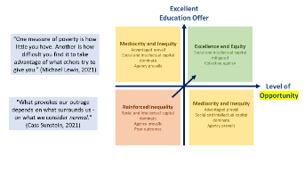
Key slides:
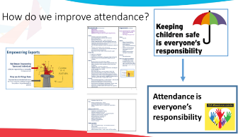
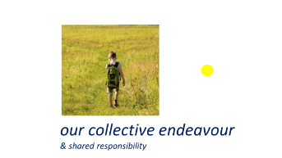

Notes made during introduction

One case study: Jamie year 2 plus lone Journal reflection task
Background
Jamie is the eldest of three children.
Jamie lives with his mum, three year old brother (Sam) and baby sister (Sophie) who is nine months old. They live 10 minutes’ walk from the school. Jamie is in receipt of the Pupil Premium.
Mum is a nurse and works two nights a week in a care home (8pm – 8am) and her mum (Grandma) usually stays over to look after the children.
Jamie’s dad lives five miles away with his new partner and two step-children, aged 5 and 7 years. Dad works locally in a 9-5pm office job (he also has flexi-time).
Dad picks up Jamie from school on a Friday and Jamie and his siblings stay with Dad and family from Friday – Sunday every other weekend.
School starts at 8:40am. Jamie arrives late to school on average twice a week. He usually arrives about 10 minutes late, but can be as late as 45 mins, which means he sometimes get an unauthorised absence mark.
Sometimes Jamie says he is hungry and that he didn’t have time for breakfast. Sometimes Jamie doesn’t bring his reading book into school and gets cross with himself, saying that he is “stupid”, because he “forgot to bring it”.
Mum does not like coming into school and often drops off at the gate. When collecting she is distracted by the other children and is reluctant to stay to talk to staff. Dad isn’t aware of the lateness or concerns about attendance as he doesn’t receive copies of letters or get invites to meetings / parents’ events.

Year 1 Attendance
In Year 1 Jamie’s overall attendance was 88%. Absence was made up of:
- U codes - arriving more than 30 mins late to school;
- broken weeks of absence, where various reasons were cited – including: had a late night so feeling tired, sore throat, cold, sickness and diarrhoea; and
- one week of unauthorised holiday in Term 6 when Dad took the children to Cornwall.
Sessions attended: 334 out of a possible 380 Including 53 L codes (Late arrival before registers close)
Total absences: 46
24 Authorised absences:
- Illness: 24 sessions
22 Unauthorised absences:
- Late after reg closes (U code): 7 sessions
- Other unauthorised absence (O code): 5 sessions
- Holiday (G code): 10 sessions
Year 2 Attendance so far
So far in Term 1, Jamie’s attendance is 94%:
Sessions attended: 62 out of a possible 66 Including 11 L codes (Late arrival before registers close)
Total absences: 4
3 Authorised absences:
- Illness: 3 sessions
1 Unauthorised absence
- Late after reg closes (U code): 1 session

Lone Journal reflection task (5 minutes)
Read the above case study having heard about it from colleaguesReflection task (5 minutes)
- How might the school environment be having an impact?
- How could the processes be further disadvantaging parental support / engagement?
- What practices could better support the family to help Jamie attend?
- How can we add advantage to Jamie’s situation?

Breakout rooms – sharing barriers/solutions (8 minutes) What barriers and solutions have you discussed?
Add to your list and notes above considering the views of others.

Coming back together for feedback/next questions (5 minutes)
Add to your list and notes above considering the views of others.

Breakout rooms – sharing solutions and ideas (10 minutes)
Think about a child you know who has poor attendance and one/more of the barriers you have discussed for our case studies.

- What could you do differently to support best attendance for this child?

Notes:

Chat feedback and next steps together ‘compelling action’ (2 mins)
Add to your list and notes above considering the views of others. List below what you will now do in your practice as a result of this discussion:

