Addressing disadvantage through dialogue

This session will emphasise the importance of oracy as a key pedagogy for all learners but particularly for those experiencing disadvantage. As well as considering its potential for impact on academic learning, it will also explore the role that classroom talk has to play in learner identities and engagement. Throughout, it will suggest strategies to support oracy and dialogic learning as well providing opportunities for colleagues to share their own practice. Finally, we will look at the intended work of the primary maths subject community in exemplifying some of these ideas for the primary curriculum through a process of action research.

The aim of the session is to provoke discussion about the importance of classroom talk across the curriculum and to suggest some useful starting points for teachers and leaders to consider taking this forward as a key strategy in addressing disadvantage in our academies.

Key slides:
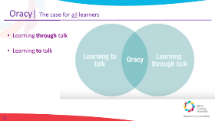
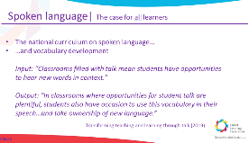

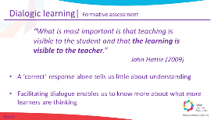
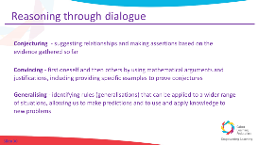
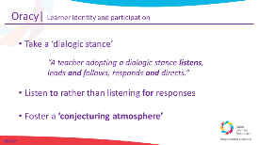

Oracy: driving learning for all
Notes:
(Slide 11) When you think of the oracy expectations in classrooms, do learners evidence more exploratory talk or more presentational talk?

Reading (5 minutes): https://voice21.org/exclusive-extract-transforming-teaching-and-learning-through-talk/

Breakout Discussion 1 (10 minutes): Notes
(slide 17) What would you like to explore further in relation to oracy?
How do you currently provide opportunities for your learners to learn through and to talk?

Notes: Dialogic learning for assessment & hard thinking

Notes: Participation & learner identity

Reflections: Your response
(Slide 28) Why does oracy matter for the learners you teach?

Notes: CLF Primary Maths: “Reasoning through dialogue”

Reflection: The impact of this PD
(Slide 36) What impact will this have on your teaching? What impact will this have on your pupils?
What is your main takeaway from this session?

Additional reading
- Transform Teaching and Learning Through Talk – Amy Gaunt & Alice Stott, 2019 (164 pages)
Practical, written for teachers and leaders, full of case studies and useful ideas
- Classroom Talk: Evidence-based teaching for enquiring teachers – Rupert Knight, 2020 (118 pages)
Very succinct yet thorough review of research and evidence
Deeper reading
A Dialogic Teaching Companion, Robin Alexander, 2020 (236 pages)

