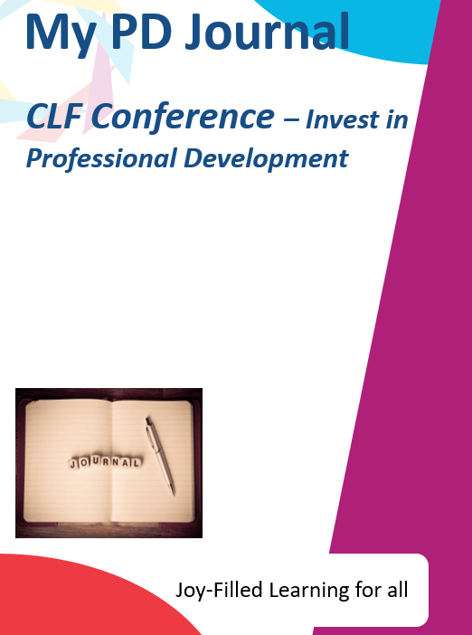

Contents
Contents
Contents 2
Getting the most out of conference 3
Modes of Learning 3
The Conference Journal 3
Effective Notetaking 3
Session 1(b) – Understanding disadvantage | seeking greater equity through education 4
Key Slides 4
My Notes: 5
Session 2 – Belonging 6
Key Slides 6
My Notes 7
Session 3 – Levelling up attendance; what can I do to support best attendance? 8
Key Slides 8
Case Study 9
My Notes 10
Case Study 10

Getting the most out of conference

Modes of Learning
The following icons describe the expectations for each and every one of us in this session. They are set out here in your journal to clearly outline the expected levels of engagement, professionalism and collaboration. These expectations link to our HEART values and are part of our trust wide investment in Professional Development, and they are designed for all of us and are here to stay!

The Conference Journal
Welcome to your journal. This conference journal is a tool and document to support your individual Professional Development. In here, for each session you will find a range of content to support you in your thinking, learning and professional engagement. The journal includes a range of the following items:
- Key extracts
- Key questions
- Space for written reflection and sketchnotes (How to Sketchnote)
- Space to consider what you will do / ideas you may have to take back to your academy

Effective Notetaking
You can read more about notetaking techniques HERE on the PD platform
Effective notetaking is often the unsung hero of the workplace. It can help you capture ideas, learn new concepts, organize your thoughts, share information, and much more—but in order for your notes to be effective, you first have to learn the right notetaking strategies.
- Focus on the Right Things
Your notes should not be a straight transcript of an entire meeting / workshop. Make sure you take down the main bullet points and any additional comments or questions you may have. The key is to focus on capturing the basic facts, key points and any questions that are raised in your mind.
- Less is More
When it comes to notes, taking less is actually more. Take down keywords, skip unneeded words, or write down partial sentences. Once you are finished with the meeting / workshop, write up a full summary while the information is still fresh in your mind. This gives you the opportunity to fill in all the blanks, so when you look back you have everything you need.
- Keep it Bold
While taking notes, make sure to highlight or bold the most important information. This allows you to more easily locate the important takeaways when skimming your notes later. If you are handwriting your notes, highlight or underline and If typing, use the highlighter, italicize, underline, and bold options to make your notes more effective.

Session 1(b) – Understanding disadvantage | seeking greater equity through education

As a Trust we are seeking greater equity through education, particularly for those who are presently (or previously) experiencing disadvantage. This session explores what it is to be disadvantaged, supports colleagues to reflect on their own experiences and explores ways of seeing the world through the lens of disadvantage. It will also explore how we apply equity to move the dial for the children and families that most need us. What if we are the hope and we fail? Particularly in more challenging and darkening times?

Key Slides

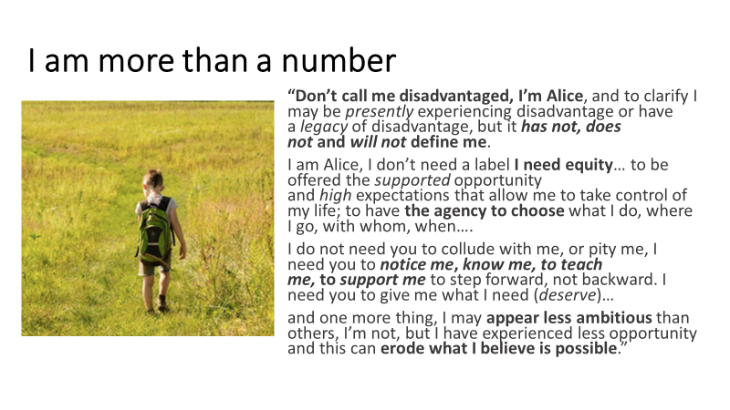
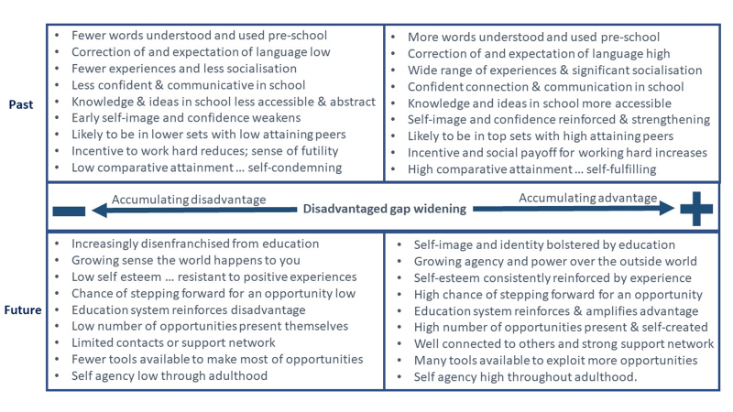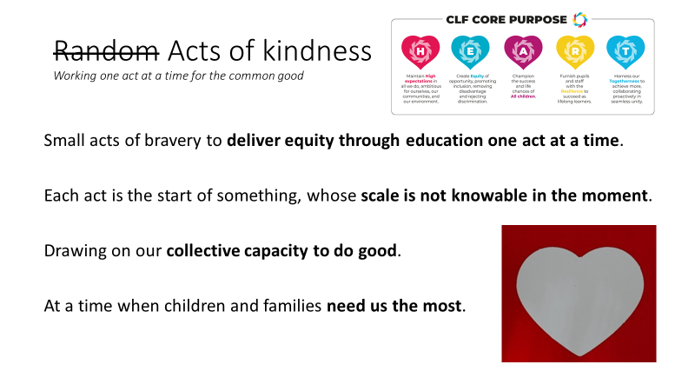

My Notes:

Understanding what it is to be disadvantaged.
How can we privilege disadvantage in all that we do?

Session 2 – Belonging

This session aims to explore what we mean by 'Belonging' and the impact that a fuller understanding of how to encourage students, staff and families to have a deeper connection to school might have.

Key Slides
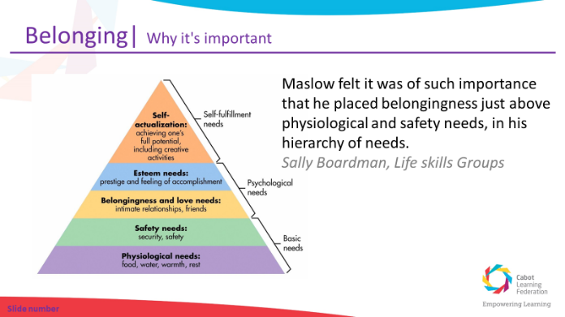

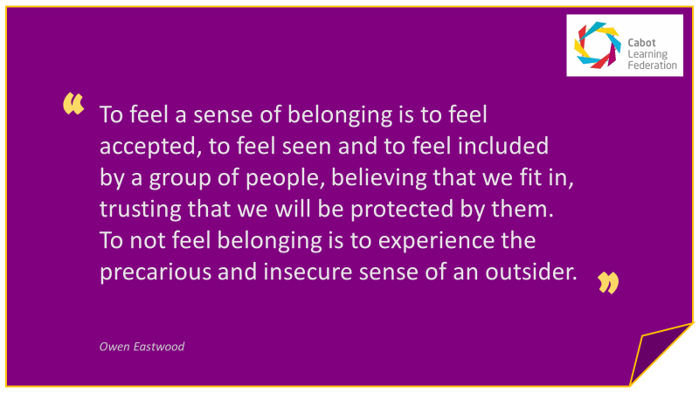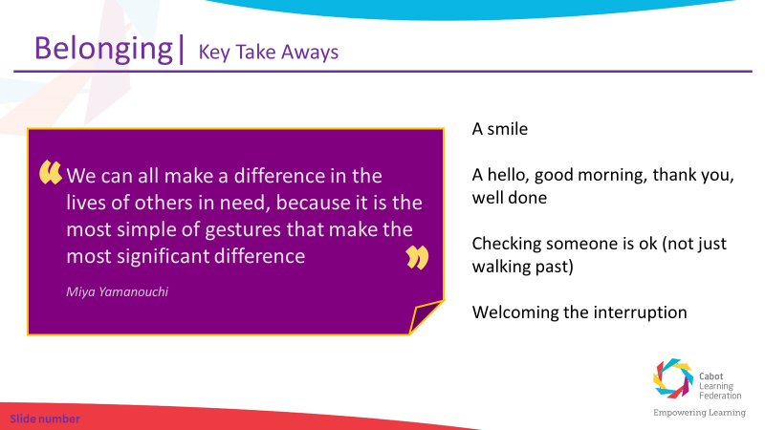

My Notes
What gives you a sense of belonging?
How does this happen?
What makes you feel valued?
What do I (we) do to create a sense of belonging?
What can I (we) do as well as, instead of or better?

Why will this better support disadvantage learners?

Session 3 – Levelling up attendance; what can I do to support best attendance?

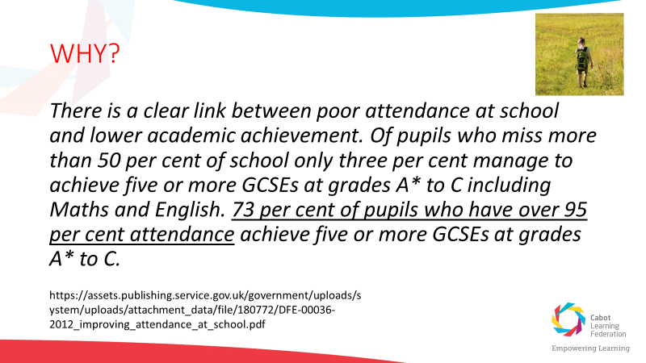
Attendance is everyone’s responsibility within an academy; not just those who have it in their job title. This session will focus on collaborative problem solving around a shared case study of a learner experiencing disadvantage, Jamie. For Jamie, attendance is a barrier to his education. Collaboratively we will discuss how we could and should support learners like Jamie in our classrooms.

Key Slides
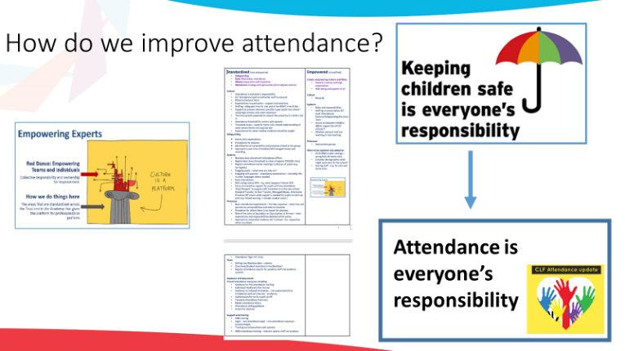
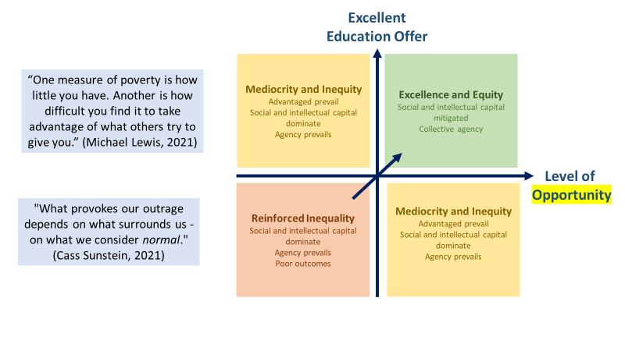

Case Study

Jamie is the eldest of three children.

Jamie lives with his mum, three year old brother (Sam) and baby sister (Sophie) who is nine months old. They live 10 minutes’ walk from the school. Jamie is in receipt of the Pupil Premium.

Mum is a nurse and works two nights a week in a care home (8pm – 8am) and her mum (Grandma) usually stays over to look after the children.

Jamie’s dad lives five miles away with his new partner and two step-children, aged 5 and 7 years. Dad works locally in a 9-5pm office job (he also has flexi-time).

Dad picks up Jamie from school on a Friday and Jamie and his siblings stay with Dad and family from Friday – Sunday every other weekend.

School starts at 8:40am. Jamie arrives late to school on average twice a week. He usually arrives about 10 minutes late, but can be as late as 45 mins, which means he sometimes get an unauthorised absence mark.

Sometimes Jamie says he is hungry and that he didn’t have time for breakfast. Sometimes Jamie doesn’t bring his reading book into school and gets cross with himself, saying that he is “stupid”, because he “forgot to bring it”.

Mum does not like coming into school and often drops off at the gate. When collecting she is distracted by the other children and is reluctant to stay to talk to staff. Dad isn’t aware of the lateness or concerns about attendance as he doesn’t receive copies of letters or get invites to meetings / parents’ events.

Year 1 Attendance
In Year 1 Jamie’s overall attendance was 88%. Absence was made up of:
- U codes - arriving more than 30 mins late to school;
- broken weeks of absence, where various reasons were cited – including: had a late night so feeling tired, sore throat, cold, sickness and diarrhoea; and
- one week of unauthorised holiday in Term 6 when Dad took the children to Cornwall.

Sessions attended: 334 out of a possible 380 Including 53 L codes (Late arrival before registers close)
Total absences: 46
24 Authorised absences:
- Illness: 24 sessions
22 Unauthorised absences:
- Late after reg closes (U code): 7 sessions
- Other unauthorised absence (O code): 5 sessions
- Holiday (G code): 10 sessions

Year 2 Attendance so far
So far in Term 1, Jamie’s attendance is 94%:

Sessions attended: 62 out of a possible 66 Including 11 L codes (Late arrival before registers close)
Total absences: 4
3 Authorised absences:
- Illness: 3 sessions
1 Unauthorised absence
- Late after reg closes (U code): 1 session

My Notes

Case Study
- How might the school environment be having an impact?
- How could the processes be further disadvantaging parental support / engagement?
- What practices could better support the family to help Jamie attend?
- How can we add advantage to Jamie’s situation?

Barriers and Solutions – what can I do to best support attendance?
My compelling actions

