Name: |  | Date:
Personal Learning Network Review
Below is a self-assessment exercise aimed at identifying the various elements that feed your own professional development and enabling you to reflect on areas for development and action steps |  |  | Use the boxes below to identify the current connections within your PLN
Organisations | Physical Networks |  |  | Blog / Website Subscriptions
Current Connections: | Current Connections: |  |  | Current Connections:
Social Networks | Alternative Domain Links |  |  | Other Links
Current Connections: | Current Connections: |  |  | Current Connections:

Personal Learning Network Balance  Shade the sections below to indicate how strong each of your PLN characteristics are. |  | PLN Connection Actions  What connections could you add to your network?
Locality – How wide does your PLN stretch (local, regional, national, international)?
Domain – Do your PLN connections stretch beyond your organisational domain?
Elements – Do you have connections for all elements of your role?
Challenge – Do you have connections that both support and challenge you?
Engagement – What role do you typically take (consumer, participant, contributor or leader)?
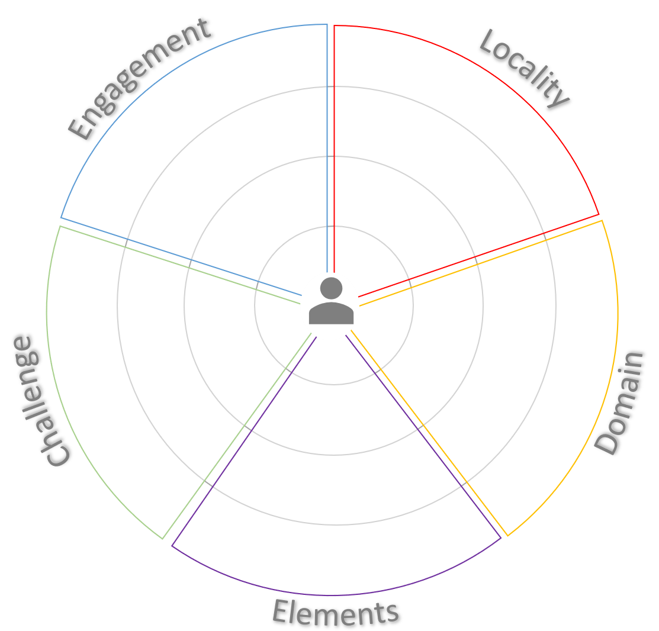
PLN Balance Actions
What connections can you add to balance your network?

