What have we learnt about curriculum in Term 1?
Part 1 - Panel Discussion
- Louisa Aldridge (Institute) Senior Network Leader for Science
- Georgie Tinker (UVA) VP, Specialism in leading English, MFL and Creative Arts
- Adele Fletcher (HWA) SLE for History, Leader of FNN.
- Charlotte Black (WFA) AP, Lead on Curriculum and T & L

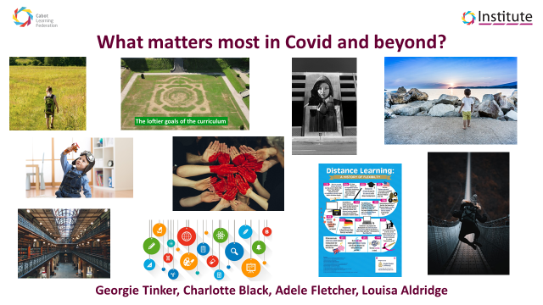
What matters most?
What has been happening in our academies?
What are the challenges for curriculum planning in Term 2?

- Charlotte Black
  - Really valued and appreciated the Aisha Ahmed discussions on reaching a block in the pandemic.
  - Having to make significant changes to our sector and this journey continues.
  - Ensuring the structure, reorganisation and the clarity of learning.
  - Being clear with learners and parents. “We are Learning this so we can…”
  - At WFA the 39 Weeks and yearlong plan has been a challenge. There have been hard decisions about content and at the same time weaving in content from last year.
  - Making changes to support gaps.
  - Considerations about how we move forward as a trust and how does our community grow to support on another.
- Louise Aldridge
  - Similar challenges of teaching in both Primary and Secondary
  - Threshold concepts need to be assessed in the classroom, frequently checking a child’s understanding.
  - Going back if necessary to make sure students really understand the concept.
  - No point in doing all the content if they do not understand any concepts.
  - Teachers need to really ensure understanding in the key areas before moving on to the next.

- Adele Fletcher
  - A need for students to be accountable and staff reiterating that learning is everywhere.
  - We need to create hotels for students to visit, and ensure there is an understanding of this terminology.
  - Shared value and shared understanding that it’s not here and now, it’s everywhere

- Georgie
  - At UVA there are some big conversations about the stamina of pupils and how to build up stamina over Term 2.
  - Ensuring that Term 2 plan is keeping pupils engaged in a period of such uncertainty.
  - An opportunity to shine a light on self-agency

- Charlotte
  - Planning needs to be of such quality, that remote learning is not a watered-down version of what is happening in school.
- Georgie
  - Schools are in a much better position than they were in March.
  - Planning is different in a pandemic and considering how things can be moved to a screen in remote learning.
- Charlotte
  - Keeping an eye on wellbeing at the same time as creating a positive remote learning experience.
- Georgie
  - Challenge in pupils writing skills, holding a pen for a period of time.
- Adele
  - Also, important to continue working on oracy during this time as this will have been lost during lockdown.
- Louisa
  - Making sure students can apply their knowledge to lots of different situations, not just remembering lots of facts. Having more than just the knowledge. This is the challenge for all teachers.
- Charlotte:
  - So many unknowns, thinking about lessons and which ones may be better for remote learning.

Part 2 - Academy Thinking
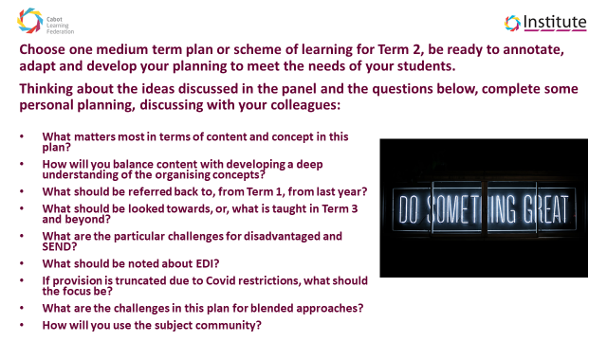
At BBA
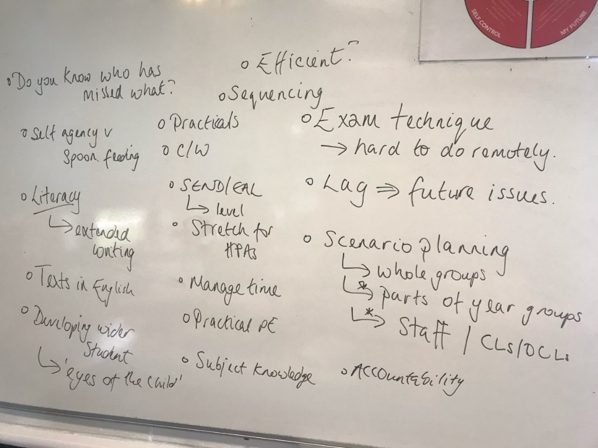
How do we track progress? How do we remain efficient? How do we approach planning creatively?
At BMA
Business planning:
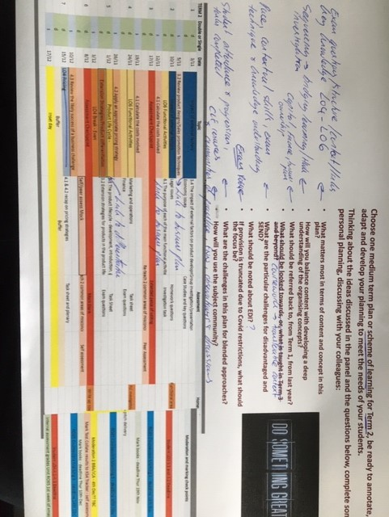
Maths discussion considering the spiral curriculum and potential missed learning from lockdown to support Yr 7 curriculum.
At HWA
The ongoing challenge of blended learning (as this becomes a more prevalent part of curriculum implementation), especially if you have a small group absent from a year group bubble. How can we provide bespoke instructional videos that align with curriculum plans, managing this alongside day to day planning? Could threshold concept videos be created centrally by curriculum curators and used as a blended learning approach?
At UPA
How can we build on success in terms of strategies identified such as Talk for Writing to scaffold and develop children's writing skills across all subject areas?
At Post 16
How do we tackle the challenges of missed learning? How we incorporate this into our different subject areas?
At HMA
How do we support children with writing? What opportunities are presented by the Historians curriculum? For example, in Year 1, their History topic for this coming term is Technology and Communication: Past and Present. The teachers have been planning for their children to write letters and postcards and then a subsequent 'trip' to a local post box to physically post their creations! A lovely, practical and memorable way to give a real purpose to their writing.
At KOAP
How do we address the massive weighting of oracy and communication in Year 1 classes? How do we facilitate conversations and increase talk within everyday provision?
Part 3 - Plenary Discussion
- Carina Smith (BA) VP
- Craig Jones (HVA) Principal
- Steve O’Callaghan (HWA) VP
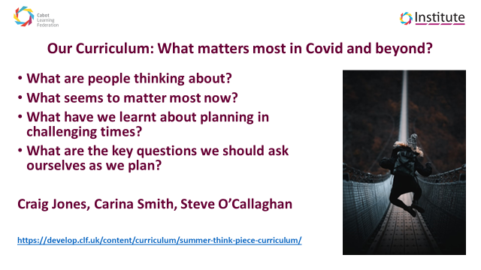

What matters most?
What have we learnt about the challenges of curriculum and planning?
So what next for Term 2?
Carina Smith (BA)
  - Teachers been working with 1/2 LSAs. Discussing what matters most in the next unit of work and what must be taught in the classrooms next term.
  - Looked at the planning with fresh eyes.
  - Making sure coherence and detail of the CLF curriculum are still observed.
  - Finding the fastest way to the learning.
  - We need to articulate what does matter most as the teachers and LSAs.
  - By the Christmas holidays, what do the children need to know?
  - Building blocks over time.
  - A helpful picture from across the school.

Comments:
- Considering who are the best adults to support our SEND pupils?
- Did you think about preconceptions and misconceptions of pupils?
- Considering what might come up and being prepared for these misconceptions.
- Looking at vocabulary – a lack of a rich vocabulary during lockdown and UVA are getting a refocus on the love of reading.

Craig Jones
- Sequence and progression learning focus.
- Teachers have been working in year groups.
- Thinking about what it means to be a ____ e.g (historian), what does a child need right now, and what matters most?
- Impressed with the team and seeing the level of detail.
- Sweating the small stuff e.g. looking closely at the letter D.
- Every day counts – no harm in providing extra exposure to fill those gaps.
- Reminder to Primaries to take advantage that teachers are English specialists and they have an opportunity to weave it into other subjects such as Geography.
- Considering barriers of the pandemic.

Steve O’Callaghan
- Echoing other groups work.
- Talking about emerging false economy between knowledge and skills. They work as a tandem. You need both to go hand in hand.
- HWA has been talking about the shortest path to learning. Challenges is to make sure you are brave to pause and dwell on some topics that need further development.
- Threshold concepts to be discussed and invested in centrally in the future?
- Blended learning – everyone has learnt a lot over lockdown. Recording short instructional videos is just one example. A useful and renewable resource, recording demonstrations for example.
- GCSE specifications are still relatively new so this is an ongoing challenge.
- This whole process was useful and insightful, calendaring more curriculum PD time across the trust and subject curriculum time in academies would be useful.

